# Scenario #: Borrow Book

## Scenario Description

The intent of this test scenario is as follows:

* When a patron wants to borrow a book, they swipe their library card and scan their books   
  so that a loan may be created and added to their borrowing record.

## Version Control

|  |  |  |  |
| --- | --- | --- | --- |
| Version # | Date | Author | Description |
| 0.1 | 26/09/2019 | Con Mougios | Initial Draft |
|  |  |  |  |

## Test Scripts

The following scripts will cover this scenario:

* 1. The book’s status is updated to ON_LOAN on successful borrowing.
  2. The loan is recorded in current loans on successful borrowing.
  3. The loan is recorded as part of the patron’s current loans on successful borrowed
  4. Borrowing book restrictions:
* No books status is updated on book not successfully borrowed.
* No loan is recorded in current loans on book not successfully borrowed.
* No change is made to the Patron’s loan record on book not successfully borrowed.
  1. Borrowing book cancelled
* No book’s status is updated.
* No loan is recorded in current loans.
* No change is made to the Patron’s loan record.

## Use Case

The use case begins when the Patron takes their books to the self-service station:

1. Patron/Librarian swipes Patron’s library card
2. System checks borrowing restrictions
3. System prompts to scan book
4. Patron/Librarian scans the books barcode
5. System adds book to current pending loan list
6. System displays book details
7. Patron/Librarian chooses to complete borrowing
8. System processes pending loan list
9. System displays borrowing success message

## Test Components/Requirements

* 1. When a patron takes out a loan, the state of the book is changed to the correct value i.e. ON_LOAN.
  2. When the patron selects “List Loans” from the Library main menu after a successful borrow, the state of CURRENT should consist of the loan being taken out by the borrower, the book name and return due date.
  3. When the patron selects “List Members” from the Library main menu after successfully borrowing a book, the LOAN section references those member(s) whom have taken out a loan as indicated by the status CURRENT along with the borrowing record i.e. book name and due date.
  4. When the patron selects “L” to take out a loan, restrictions are enforced and a message to indicate that the member cannot borrow a book.
  5. When a patron cancels a book borrowing operation

## User Groups

* User group/responsibility 1
* User group/responsibility 2

## Script #: 1.1 Status is updated to ON_LOAN

### Script Description

* Check the book status has correctly transitioned from AVAILABLE to ON_LOAN i.e. once the patron has successfully borrowed the book

### Testing Requirements

* Take out a loan and check the state of the book is changed to the correct value after successfully borrowing a book

### Setup

* Run main.java to present the Library main menu

### Teardown

* List all steps that should be taken after the test case is executed

### Script Steps

| **Step #** | **Test Action** | **Expected Results** | **Pass/ Fail** |
| --- | --- | --- | --- |
| 1 | User enters “L” | System prompts to swipe member card | Pass |
| 2 | User enters value of “1” | Book is scanned in and its book details displayed | Pass |
| 3 | User presses “enter” | System prompts Y/N to complete the loan | Pass |
| 4 | User enter “Y” | System displays loan slip with book and borrowers’ details followed by a prompt to press any key to complete | Pass |
| 5 | User presses “enter” | System displays to screen that the borrowing has been completed and return to the main menu | Pass |
| 6 | User presses “LB” | System list the borrowed book with the status changed to “ON_LOAN” | Pass |

### Test Execution

|  |  |  |  |  |
| --- | --- | --- | --- | --- |
| Date/Time | Tester | Test ID | Test Phase | Status |
| 2/12/06 11:35 am | Joseph Jones | Samsmith1 | System Cycle 1 | Passed (Refer to screenshot 1) |

Screenshot 1:

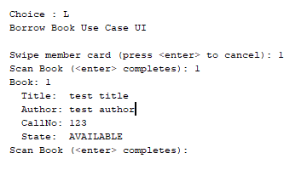

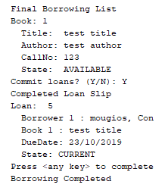

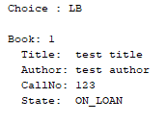

## Script #: 1.2 Loan recorded in current loans

### Script Description

* Check the book loan has correctly been assigned to the successful borrower and its status correctly changed

### Testing Requirements

This test script covers the following specific testing requirements:

* The “List Loans” captures the loan id, borrowers id, book title, due date and loan status.

### Setup

* Run main.java to present the Library main menu

### Teardown

* List all steps that should be taken after the test case is executed

### Script Steps

| **Step #** | **Test Action** | **Expected Results** | **Pass/ Fail** |
| --- | --- | --- | --- |
| 1 | User enters “LL” from the main menu | Display loan id, borrower, id, book title, due date and state changed to CURRENT | Pass |

### Test Execution

|  |  |  |  |  |
| --- | --- | --- | --- | --- |
| Date/Time | Tester | Test ID | Test Phase | Status |
| 2/12/06 11:35 am | Joseph Jones | Samsmith1 | System Cycle 1 | Passed (Refer to screenshot 1) |

Screenshot 1:

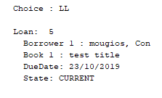

## Script #: 1.3 Loan recorded in patrons’ current loans

## Script Description

* Check patron loans are recorded after successfully borrowing a book.

### Testing Requirements

This test script covers the following specific testing requirements:

* The “List Members” captures each patron loan details after a successful borrow

### Setup

* Run main.java to present the Library main menu

### Teardown

* List all steps that should be taken after the test case is executed

### Script Steps

| **Step #** | **Test Action** | **Expected Results** | **Pass/ Fail** |
| --- | --- | --- | --- |
| 1 | User enters “LM” from the main menu. | Display the members and loan details | Pass |

### Test Execution

|  |  |  |  |  |
| --- | --- | --- | --- | --- |
| Date/Time | Tester | Test ID | Test Phase | Status |
| 2/16/06 3:45 pm | Joseph Jones | Samsmith1 | System Cycle 1 | Passed (Refer to screenshot 1) |

Screenshot 1:

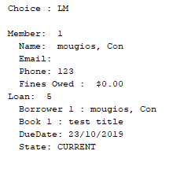

## Script #: 1.4 Borrowing Restrictions

### Script Description

* Borrowed books that have restrictions enforced should not update any of the patrons, books or loan records

### Testing Requirements

This test script covers the following specific testing requirements:

* The book, loan and patrons loan records status are not updated as a result of an unsuccessful borrowing of a book.

### Setup

* Member has exceeded borrowing threshold of two books.
* Member has overdue books
* Member has fines

### Teardown

* List all steps that should be taken after the test case is executed

### Script Steps

| **Step #** | **Test Action** | **Expected Results** | **Pass/ Fail** |
| --- | --- | --- | --- |
| 1 | Use enters “L” from the main menu | System displays “member cannot borrow at this time” | Pass |
| 2 | Use enters “LM” from the main menu | System displays status of OVER_DUE Loan record for patron remains unchanged | Pass |
| 3 | Use enters “LL” from the main menu | System displays status of OVER_DUE i.e. no loans have been taken out as CURRENT | Pass |

### Test Execution

|  |  |  |  |  |
| --- | --- | --- | --- | --- |
| Date/Time | Tester | Test ID | Test Phase | Status |
| 2/16/06 3:45 pm | Joseph Jones | Samsmith1 | System Cycle 1 | Passed (Refer to screenshot 1) |
| 2/16/06 3:45 pm | Joseph Jones | Samsmith1 | System Cycle 2 | Passed (Refer to screenshot 2) |
| 2/16/06 3:45 pm | Joseph Jones | Samsmith1 | System Cycle 3 | Passed (Refer to screenshot 3) |

Screenshot 1: (Restrictions enforced):

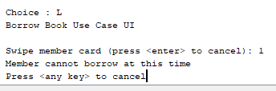

Screenshot 2: (no changes made to patron’s loan record)

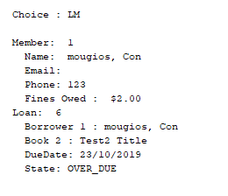

Screenshot 3: (no loan is recorded in current loans)

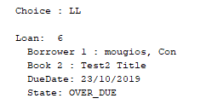

## Script #: 1.5 Borrowing Cancelled

### Script Description

* Cancelled borrowing operations should not update any of the patrons, books or loan records

### Testing Requirements

This test script covers the following specific testing requirements:

* The book, loan and patrons loan records status are not updated as a result of a patron conducting cancellation on borrowing a book.

### Setup

* Run main.java to present the Library main menu

### Teardown

* List all steps that should be taken after the test case is executed

### Script Steps

| **Step #** | **Test Action** | **Expected Results** | **Pass/ Fail** |
| --- | --- | --- | --- |
| 1 | Use enters “L” from the main menu | System displays “swipe member card” | Pass |
| 2 | Use enters “2” | System displays “scan book” | Pass |
| 3 | Use enters “3” | System displays book details and prompts to enter to complete scanning of book | Pass |
| 4 | User hits “enter” | System display final borrowing list and prompts user to commit loans Y/N | Pass |
| 5 | User enters “N” | System displays borrowing cancelled | Pass |
| 6 | User enters “LM” | System displays member details without any loan taken out | Pass |
| 7 | User enter “LB” | System displays loan book details with status unchanged | Pass |

### Test Execution

|  |  |  |  |  |
| --- | --- | --- | --- | --- |
| Date/Time | Tester | Test ID | Test Phase | Status |
| 2/16/06 3:45 pm | Joseph Jones | Samsmith1 | System Cycle 1 | Passed (Refer to screenshot 1) |
| 2/16/06 3:45 pm | Joseph Jones | Samsmith1 | System Cycle 2 | Passed (Refer to screenshot 2) |
| 2/16/06 3:45 pm | Joseph Jones | Samsmith1 | System Cycle 3 | Passed (Refer to screenshot 3) |

Screenshot 1(borrowing cancelled):

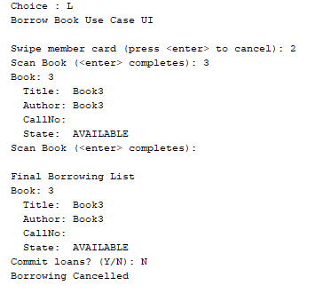

Screenshot 2: (No loans taken out for member (LM))

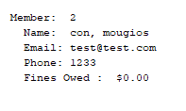

Screenshot 3: (Loan state unchanged (LB))

